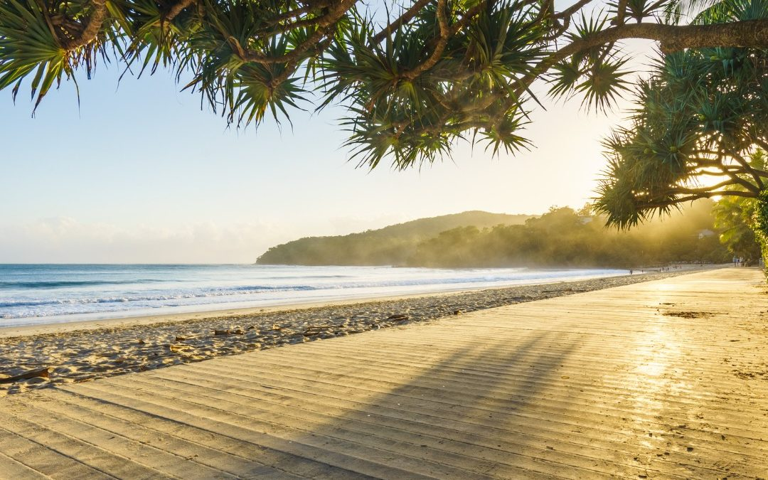

**Oceania Senior Chess Championship**

**14 - 20 November 2021**

**Noosa, Queensland**

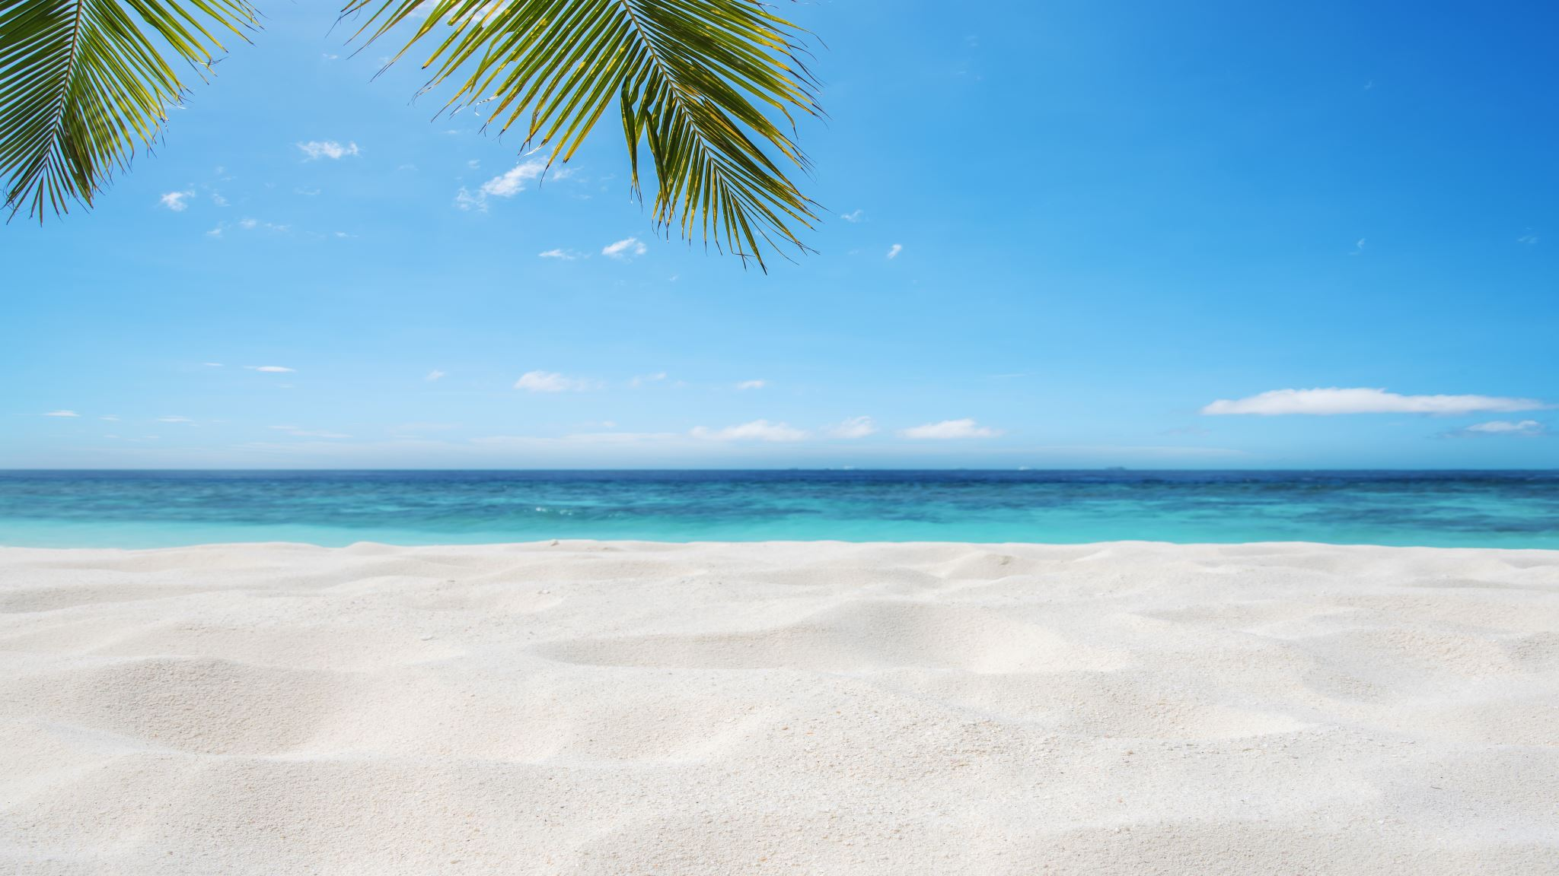

The 2021 Oceania Senior Chess championship

incorporating the Australian Senior Chess Championship will be played in Queensland’s Premier Tourism Venue, Noosa, over 7 days

from 14th November 2021

* 7 Rounds over 7 days (up to 2 byes in rounds 1-5)
* Additional Rapid & Blitz Tournaments
* Noosa Novice Tournament

Location: Tewantin/Noosa RSL Club, 1 Memorial Ave, Tewantin

Extensive excursions, fine dining and accommodation options

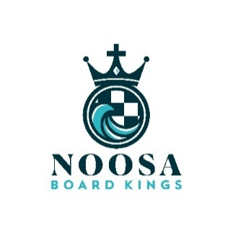

Proudly hosted by the Noosa Shire Chess Club

ENTRY FORM

Oceania Senior Chess Championship

Incorporating Australian Senior Chess Championship

14 - 20 November 2021

|  |
| --- |
| **Name:** |
| **Address:** |
| **Mobile: Email:** |
| **Date of Birth (born up to 31 Dec 1971):** |
| **Nationality: Current rating FIDE: National rating:** |
| **Affiliations (state assoc, clubs etc):** |
| **FIDE titles (if any):** |
| **Other titles / most significant championship wins (present and past):** |
| **Entry fee (please tick)**  **( ) $200 - Full Entry**  **( ) $150 - Concession (pensioners)**  **( ) $200 - Early Bird (up to 31 July) includes free entry to Blitz and Rapid**  **( ) $150 - Early Bird Concession (up to 31 July)** |
| **Payments by bank transfer:**  **Noosa Shire Chess Club Inc.**  **BSB 064 449**  **Account 1052 9496** |

Chess Schedule

Sunday 14th – Saturday 20th November

|  |  |  |  |
| --- | --- | --- | --- |
|  | **Championships** | **Other Events** | **Noosa Novice** |
| **Sunday 14th** | 1430 Round One |  |  |
| **Monday 15th** | 1030 Round Two |  |  |
| **Tuesday 16th** | 1030 Round Three | 1500-1900 Blitz |  |
| **Wednesday 17th** | 1030 Round Four | 1500-1900 Rapid | 1700-2200 Rounds 1-3 |
| **Thursday 18th** | 1030 Round Five | 1500-1900 Rapid | 1700-2200 Rounds 4-6 |
| **Friday 19th** | 1030 Round Six |  | 1700-1900 Round 7 and prizes |
| **Saturday 20th** | 1030 Round Seven  1700 Closing Ceremony |  |  |

Proudly brought to you by Noosa Shire Chess Club and partners



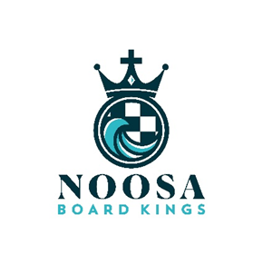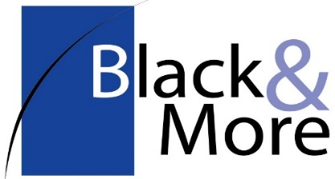

ACCOMMODATION

Please refer to the Accommodations page and enter your requests here. We can adjust for 6, 7, 8 nights or longer. Arcadia Travel will advise payment and cancellation terms.

|  |  |  |  |
| --- | --- | --- | --- |
|  | Studio apt | One bedroom apt | Two bedroom apt for up to 4 persons (2 bathrooms) |
| Noosa Lakes Resort (3.5*) | 22 sqm $115 per nt / 6-8 nts,  kitchenette,  no housekeeping | 50 sqm $150 per nt / 6-8 nts,  full kitchen,  no housekeeping | enquire |
| Peppers Noosa Heads (5*)  Breakfast at View Restaurant |  | 45 sqm $290 per nt / 6-8 nts, full kitchen,  daily servicing, breakfasts | 70 sqm $440 per nt / 6-8 nts  daily servicing, breakfasts |
| Netanya (5*) | not offered | $560 per nt / 6-8 nts (non-beach)  $720 per nt / 6-8 nts (beachfront) | enquire |

For other deals at these and other accommodations you’re welcome to browse the internet then ask us for a quote.

|  |  |  |  |
| --- | --- | --- | --- |
| ARRIVAL | DEPARTURE | NUMBER OF NIGHTS | DOUBLE OR TWIN BEDS? |
|  |  |  |  |

|  |  |  |  |
| --- | --- | --- | --- |
| ADITIONAL PERSONS: |  |  |  |

EXCLUSIVE ACTIVITIES & DINNERS

For now, for planning our exclusive activities, please indicate your interest from 1 (count me out) to 5 (absolutely!):

|  |  |  |
| --- | --- | --- |
| 1 2 3 4 5 | Sunset Cruise charter up the Noosa River to Lake Cooroibah 2 hours (Monday 6pm, 60 places) | $15 |
| 1 2 3 4 5 | Walk through Noosa National Park (days/times to be set) | free |
| 1 2 3 4 5 | Noosa Bike Hire 7 days mtb, includes helmet and lock | $100 |
| 1 2 3 4 5 | Afternoon Brewery Tour | $75 est |
| 1 2 3 4 5 | Feast dinner at Peppers View Restaurant (chef Matt Golinski) Tue 7:30pm (min 10, max 50 diners) | $90 |
| 1 2 3 4 5 | Farewell dinner at RSL Bistro Saturday 6pm (90 places) | TBA |

We’ll start firming these events after Early Bird Bookings close on 31 July

Below are recommended accommodations with special deals (and cancellation conditions)

|  |
| --- |
| Noosa Lakeside Resort and Convention Centre (3.5*):  Close to venue (600m) and Noosa Marina restaurants (300m), good value and with self-catering. www.noosalakesresort.com.au |
| Peppers Resort (5*):  Close to Hastings St precinct, a ferry or bus ride to the venue, self-catering, onsite 'View Restaurant' (chef Matt Golinski), medium cost. www.peppers.com.au/noosa |
| Netanya (5*):  Fronting Main Beach on Hastings St and next door to the Noosa Surf Club - if you'd like to experience Noosa 'to the max'.  The hotel is undergoing an $11m rebuild this winter, due to re-open September. www.netanyanoosa.com.au |

You can book other accommodation with us:

If you do choose your own, browse for properties and rates on the internet and if the best rate is matched by Expedia, we invite you to book through Arcadia Travel, one of our sponsors. Arcadia is an agent for Expedia and will give you a slightly better rate with the remainder of agent commission going into the event sponsorship.

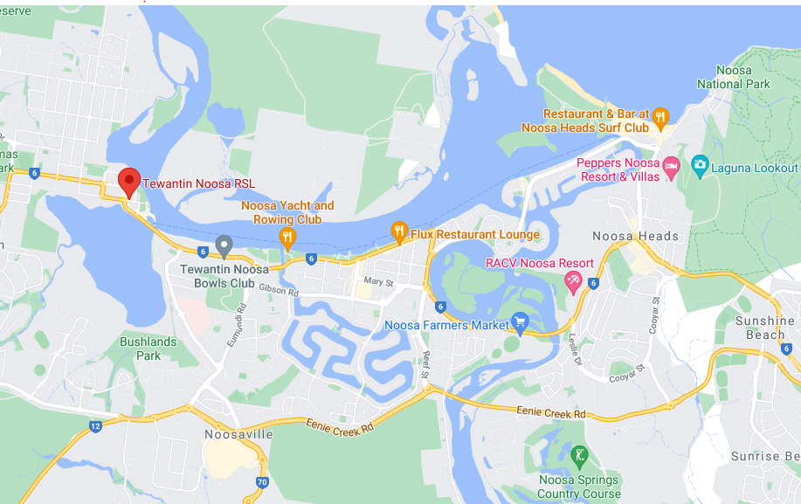

AIRPORT TRANSFERS

In October we will ask for your flight details and if you would like transfers arranged. We propose to run a number of transfer services exclusive to participants to match peak arrival and departure times for both MCY (Maroochydore, Sunshine Coast) and Brisbane airports.

Anticipated charges each way $30 pp Sunshine Coast / $50 pp Brisbane.

TRAVEL BETWEEN ACCOMMODATION AND THE VENUE

Noosa Heads, Noosaville: by bus (4 x per hour) or ferry (arrives 1020, 10 mins before 1030 starts)

Noosa Lakes Resort: walk 600m

RSL courtesy bus: departs at half-past the hour from the RSL for Noosaville and Noosa Heads, from 1730 to 2230.

Days off and excursions/activities:

Up to 2 byes: In rounds 1 to 5, up to 2 byes are permitted.

Requests for byes can be made in advance or before the start of the preceding round.

Activities, adventures, activities, spas, fine dining...

We will schedule a number of exclusive activities and offer many more from Noosa's great range.

Closer to the event we will present to participants and partners.

Bookings can be made via Arcadia Travel in advance or at the travel desk during the tournament. The week of the tournament is not a busy week in Noosa so late availability should still be good.

Support or sponsor the event

We invite contributions and/or sponsorships of $500 (or more) to help Noosa CC make this a brassy event. If you have a business or services you would like to display and we can acknowledge, we offer the opportunity to bring and display a 2m pull-up banner inside the playing hall.

